|  |
| --- |
| Experiment No. 3 |
| Quick Sort |
| Date of Performance: |
| Date of Submission: |

**Experiment No. 3**

**Title:** Quick Sort

**Aim:** To implement Quick Sort and Comparative analysis for large values of ‘n’.

**Objective:** To introduce the methods of designing and analyzing algorithms.

**Theory:**

The merge sort algorithm closely follows the divide-and-conquer paradigm. Intuitively, it operates as follows:

1. Divide: Divide the n-element sequence to be sorted into two subsequences of n=2 elements each.
2. Conquer: Sort the two subsequences recursively using merge sort.
3. Combine: Merge the two sorted subsequence to produce the sorted answer.

Partition-exchange sort or quicksort algorithm was developed in 1960 by Tony Hoare. He developed the algorithm to sort the words to be translated, to make them more easily matched to an already-sorted Russian-to-English dictionary that was stored on magnetic tape.

Quick sort algorithm on average, makes O(n log n) comparisons to sort n items. In the worst case, it makes O(n2) comparisons, though this behavior is rare. Quicksort is often faster in practice than other O(n log n) algorithms. Additionally, quicksort's sequential and localized memory references work well with a cache. Quicksort is a comparison sort and, in efficient implementations, is not a stable sort. Quicksort can be implemented with an in-place partitioning algorithm, so the entire sort can be done with only O(log n) additional space used by the stack during the recursion.

Quicksort is a divide and conquer algorithm. Quicksort first divides a large list into two smaller sub-lists: the low elements and the high elements. Quicksort can then recursively sort the sublists.

1. Elements less than pivot element.

2. Pivot element.

3. Elements greater than pivot element.

Where pivot as middle element of large list. Let’s understand through example:

List : 3 7 8 5 2 1 9 5 4

In above list assume 4 is pivot element so rewrite list as:

3 1 2 4 5 8 9 5 7

Here, I want to say that we set the pivot element (4) which has in left side elements are less than and right hand side elements are greater than. Now you think, how’s arrange the less than and greater than elements? Be patient, you get answer soon.

**Example:**

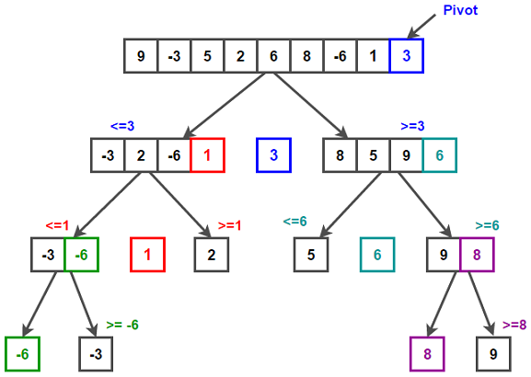

/* low --> Starting index, high --> Ending index */

quickSort(arr[], low, high)

{

if (low < high)

{

/* pi is partitioning index, arr[pi] is now

at right place */

pi = partition(arr, low, high);

quickSort(arr, low, pi - 1); // Before pi

quickSort(arr, pi + 1, high); // After pi

}

}

/* This function takes last element as pivot, places

the pivot element at its correct position in sorted

array, and places all smaller (smaller than pivot)

to left of pivot and all greater elements to right

of pivot */

partition (arr[], low, high)

{

// pivot (Element to be placed at right position)

pivot = arr[high];

i = (low - 1) // Index of smaller element and indicates the

// right position of pivot found so far

for (j = low; j <= high- 1; j++)

{

// If current element is smaller than the pivot

if (arr[j] < pivot)

{

i++; // increment index of smaller element

swap arr[i] and arr[j]

}

}

swap arr[i + 1] and arr[high])

return (i + 1)

}

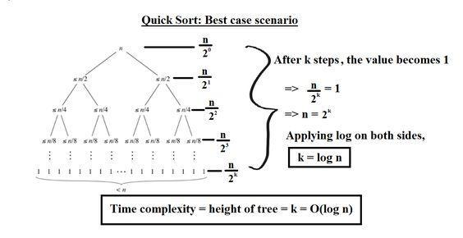

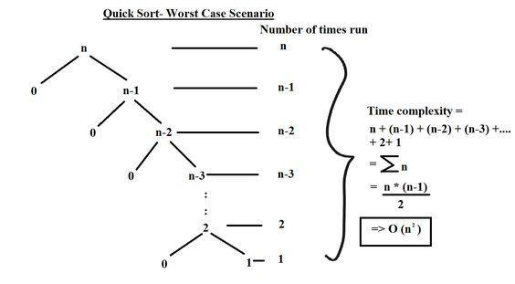

**Implementation:**

**Code:**

#include <stdio.h>

#include<conio.h>

void swap(int* a, int* b) {

    int temp = *a;

    *a = *b;

    *b = temp;

}

int Partition(int a[], int low, int high) {

    int x = a[high];

    int i = low - 1;

    int j;

    for (j = low; j <= high - 1; j++) {

        if (a[j] <= x) {

            i++;

            swap(&a[i], &a[j]);

        }

    }

    swap(&a[i + 1], &a[high]);

    return (i + 1);

}

void QuickSort(int a[], int low, int high) {

    if (low < high) {

    int q = Partition(a, low, high);

    QuickSort(a, low, q - 1);

    QuickSort(a, q + 1, high);

    }

}

int main() {

    int a[] = {7, 6, 10, 5, 9, 2, 1, 15, 7};

    int n = sizeof(a) / sizeof(a[0]);

    int i;

    QuickSort(a, 0, n - 1);

    printf("Sorted array: ");

    for (i = 0; i < n; i++) {

    printf("%d ", a[i]);

    }

    getch();

    return 0;

 }

Output:

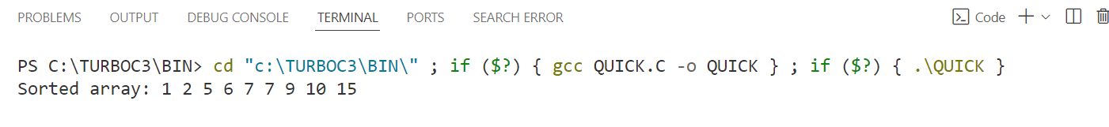

**Conclusion:** In conclusion, the Quick Sort algorithm efficiently sorts an array of integers in ascending order. It employs a divide-and-conquer strategy, recursively dividing the array into smaller subarrays based on a chosen pivot element, and then sorting those subarrays independently.

The core of the Quick Sort algorithm lies in the partitioning step, where elements are rearranged such that all elements smaller than the pivot are placed before it, and all elements larger than the pivot are placed after it. This partitioning process is pivotal for the algorithm's efficiency.

Quick Sort exhibits a time complexity of O(n log n) on average, making it one of the fastest sorting algorithms in practice. However, in the worst-case scenario, it can degrade to O(n^2), particularly when poorly chosen pivots result in highly unbalanced partitions.